Instructions for Configuring Outlook on Your Computer
- Open Control Panel by pressing the Start button and typing “Control Panel”
- Open the “Mail” settings
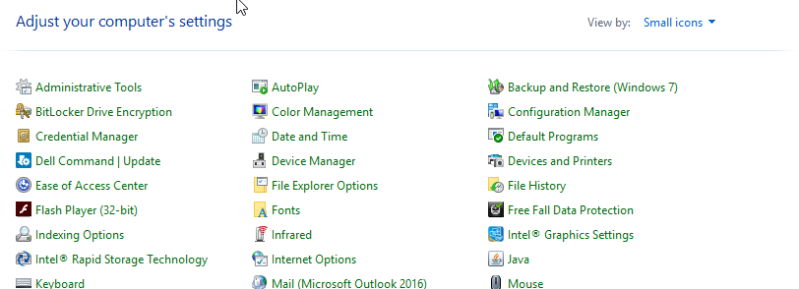
- Select “Show Profiles”
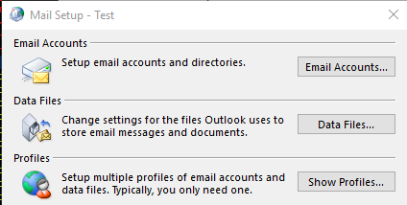
- Click “Add” to create a new profile
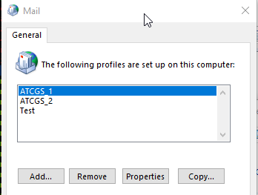

- For Profile name, put “OneAtlas_O365” and press OK
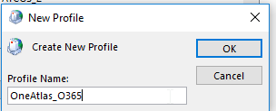
- Verify that the Email address that populates is your @OneAtlas.com email account. If needed, change it to @OneAtlas.com and input your Password twice.
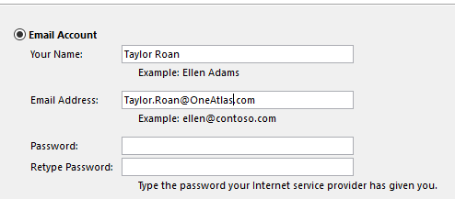
- Press Next and it will setup the rest of the account for you automatically.
- On the Mail settings window again, make sure that the “Always use this Profile” is set to the new profile that you just created.
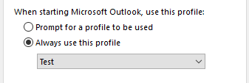
- Press Okay and close control panel.
- Open Outlook and it will setup your account. This may take a few minutes

