Configuring Office 365 Email on iPhone/Android
- Open the Outlook App and select the settings button on the bottom left. To get to this menu, press either your intials on the top left (iPhone) or the three bars on the top left (Android)
- In the settings menu, Select your existing OneAtlas email account
- In the settings for your email account, select “Delete Account”
- Return to the Settings page if you aren’t brought there automatically and select “Add Mail Account”.
  - 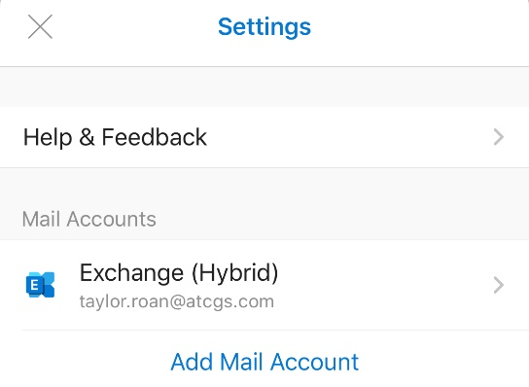
- It will ask you for your email address, use your @OneAtlas.com address.
  - 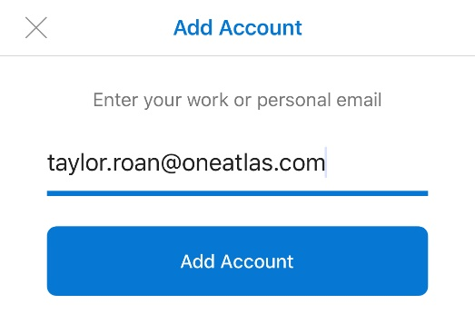
- Enter the Password that you setup for this account when asked and Outlook will pull all of the information for you automatically.

