Changing Your Office 365 Password
Before configuring email on your phone or computer, you must change your password from the Default password that was configured during the migration
- Open a browser to https://sso.oneatlas.com/adfs/portal/updatepassword
- Enter your OneAtlas.com Email address in the form of firstname.lastname@oneatlas.com in the first field. In the next field, enter the default password “Welcome1!” (without the quotes). Tab to the next field and enter the new password of your choice. Finally, tab to the last field, reenter the new password, and click “Submit.”
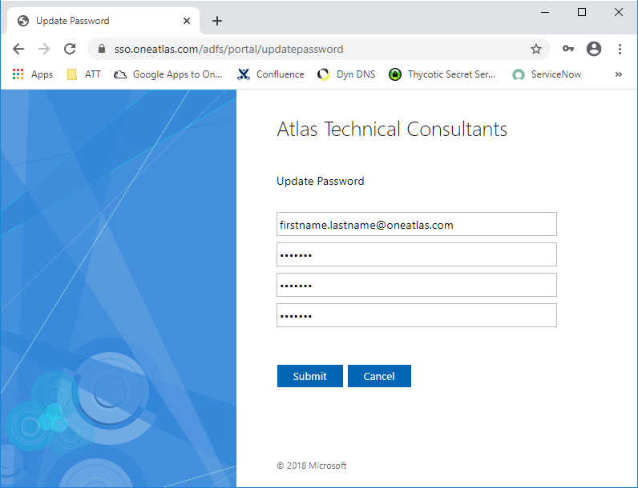

- Confirm that your password was successfully reset.

